Organic Chemistry
Class of Compound | Structural Formula | Semi-Structural Formula | Suffix | Prefix | Polarity
Alkene |  | -CHCH- | -ene |  | Slightly polar  - Weak Dipole-Dipole  -Dispersion
Haloalkane | 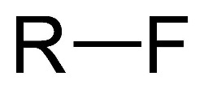 | -F  -Cl  -Br  -I |  | -Fluoro  -Chloro  -Bromo  -Iodo | Polar  -H-Bonding only if another molecule has H-FON  -Dipole-Dipole  -Dispersion forces
Alcohol | 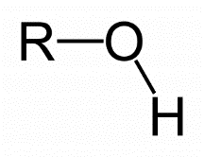 | -OH | -(an)ol | Hydroxy- | Very Polar  -H-Bonding  -Dipole-Dipole  -Dispersion forces
Aldehyde | 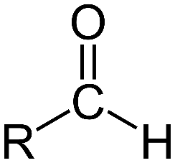 | -CHO | -(an)ane | Oxo- | Polar  -H-Bonding only if another molecule has H-FON  -Dipole-Dipole  -Dispersion
Ketone | 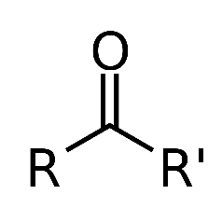 | -CO- | -(an)one | Oxo- | Polar  -H-Bonding if another molecule has H-FON  -Dipole-Dipole  -Dispersion
Carboxylic Acid | 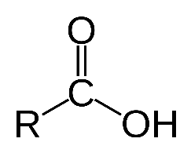 | -COOH | -(an)oic acid |  | Very Polar  -H-Bonding  -Dipole-Dipole  -Dispersion
Ester | 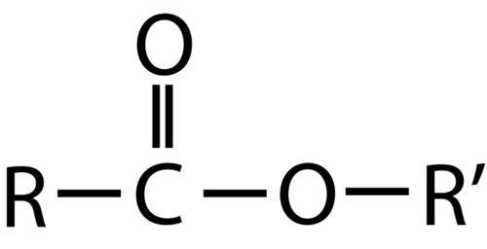 | -COO- | -(an)oate |  | Very Polar  -H-Bonding if another has H-FON  -Dipole-Dipole  -Dispersion
Amine | 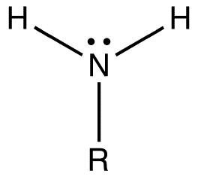 | -NH₂ | -amine | amino | -Very Polar  -H-Bonding  -Dipole-Dipole  -Dispersion
Amide | 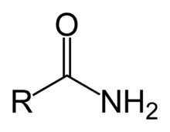 | -CONH₂ | -amide |  | Very Polar  -H-Bonding  -Dipole-Dipole  -Dispersion

Functional Groups
- As size of any molecule increases, dispersion forces become increasingly significant ⇒ interact primarily through dispersion ⇒ Soluble in non-polar molecules ⇒ Less soluble in Polar substances
- Side chains go in brackets:
  - Ex. methyl-propane: CH₃CH(CH₃)CH₃
- Alphabetical order for functional group prefixes (Ethyl named and numbered before methyl)
- DON’T use di/tri prefixes for alphabetical ordering
- Isomers have same molecular formula but different structural formula

Cycloalkanes (cyclo-R)
- General formula: C_{n}H_{2n}
- Ring structure with no double bonds
- Properties similar to alkanes
- Numbering of attached functional groups need to add up to lowest possible number

Cycloalkene (cyclo-R-ene-R’)
- Same as cycloalkane but only one is hydrogen attached to carbons involved in double bond
- General formula: C_{n}H_{2n-2x} where x is number of double bonds
- Double bond needs to be between 1 and 2 in numbering (start at double bond)

Alcohol (-OH)
- Alcohols can be described as primary, secondary or tertiary alcohols
  - Primary ⇒ -OH group at the end (bonded carbon only bonded to 1 other carbon atom)
  - Secondary ⇒ -OH group in middle (bonded carbon bonded to 2 other carbon atoms
  - Tertiary ⇒ -OH group in middle (bonded carbon bonded to 3 other carbon atoms)
- Primary and secondary alcohols can be oxidised to form other substance; tertiary alcohols cannot be oxidised:
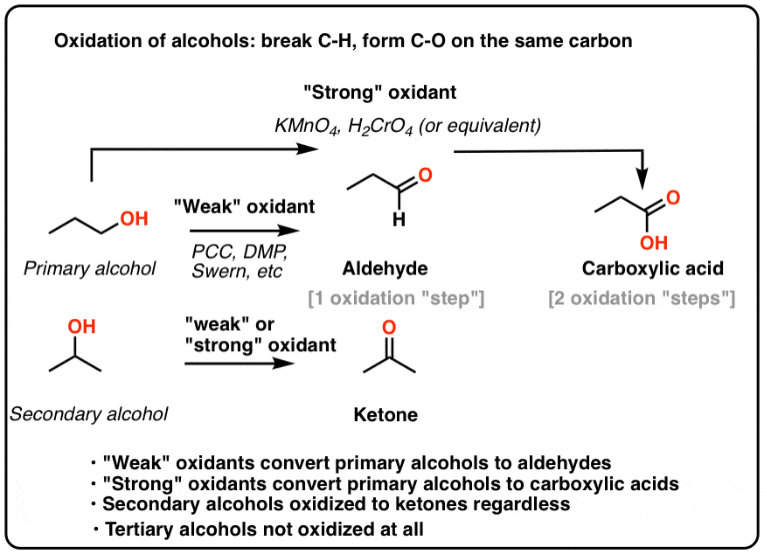
Properties
- BP of any alcohol is much higher than parent hydrocarbon ⇒ -OH capable of H-Bonding and dipole-dipole and increases mass, hence higher dispersion forces
- Soluble in any other substance capable of H-bonding or dipole-dipole forces ⇒ Solute-Solvent forces overcome constituent Solute-Solute and Solvent-Solvent forces
  - Completely miscible in H2O
- When 2+ functional groups are present, principal functional group is given priority (high to low):
- Ester (-COO-)
- Carboxylic acid (-COOH)
- Amide (-CONH2)
- Aldehyde (-CHO)
- Ketone (-CO-)
- Alcohol (-OH)
- Amine (-NH2)
- Aromatics
- Alkene (-C=C-)
- Alkyne (-C≡C-)

Benzene
- C₆H₆, flat hexagonal structure
- C-C bonds are identical, intermediate in length
- C bonds alternatively double bonded to neighbouring C atoms
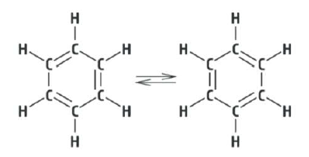
- Shorthand notations:
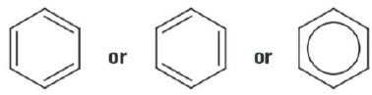
- Aromatic compounds are benzene based ⇒ H replaced with atoms or molecules
- Carcinogen

Aldehyde (-CHO)
- Polar molecule but unable to bond through H-Bonding (lacks hydrogen atom bonded to FON)
  - Can bond with other molecules with H-FON with lone electron pair on O atom
- Higher BP than parent alkane but lower BP than alcohols of same size
- Soluble in compounds with molecules capable of dipole-dipole interaction
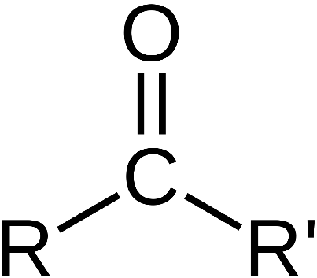
- Carbonyl group:

Ketones (-ROR₁-)
- Polar molecule and will interact primarily through dipole-dipole interactions
- Similar BP to Aldehyde of same mass
- Product of 2nd degree alcohol oxidation

Carboxylic Acid (-COOH)
- Short chain carboxylic acids have a pungent vinegary odour
- Contains -COOH, the Carboxyl functional group (Carbonyl + Hydroxyl)
- Polar molecule and will interact primarily through H-Bonding
- BP much higher than any other hydrocarbon of similar molecule size
- BP slightly higher than corresponding main-chain alcohol
- Soluble in polar solvents, especially those with H-Bonds
- As length of carboxylic acid increases greater than hexanoic acid, substance becomes virtually immiscible
- Long carboxylic acid molecules are known as fatty acids
  - Soft, greasy feel
  - Insoluble in water
- Fatty acids occur in many living systems
- Carbon chain in plant fatty acids are unsaturated (contain alkene and alkyne functional groups) and double bonds form cis configuration
- Animal fatty acids are saturated (contain no alkene or alkyne functional group)
- Fatty acids are related to, but not the same as fats and oils
- In plants and animals, fatty acids are converted to triglycerides (fats and oils)
  - Fats and oils are important for energy storage

Amines (-NH₂)
- Polar and capable of H-Bonding ⇒ BPs higher than hydrocarbons but lower than alcohols of similar molecular size
- Weaker H-bonding of amine than alcohol occurs due to lower electronegativity of nitrogen (3.0) compared to oxygen (3.5) ⇒ weaker dipole and H-Bond
- Soluble in polar solvents, especially those with H-bonds

Amides (-CONH₂)
- Individual H-Bonding strength is greater than similar amines or carboxylic acids:
  - Greater number of suitable lone electron pairs and H atoms available for H-bonding in amide (2 H-atoms and 3 lone pairs) than similar amine or carboxylic acid
  - Close proximity of highly electronegative O atom causes H atoms from NH₂ group to develop larger dipole than normal
- Therefore, BP of amides are higher than amines, alcohols, and carboxylic acid
- Soluble in other solvents which interact strongly through H-bonds

Esters (-COO-)
- Ester group creates a degree of polarity at centre of ester molecule
  - Allows for dipole-dipole and dispersion interactions
  - H-Bonding?
- Therefore, BP is similar to aldehydes and ketones but lower than alcohols and carboxylic acids of similar molar mass
- Pleasant fruity odours for small molar mass esters
- High molar mass esters are solid with a waxy feel
- Lower molar mass esters are volatile
- Used as solvents
- Useful for adding fruity and floral odours in foods and cosmetics
- Leaves of most plants have protective wax coating of high molar mass esters
- Esterification:
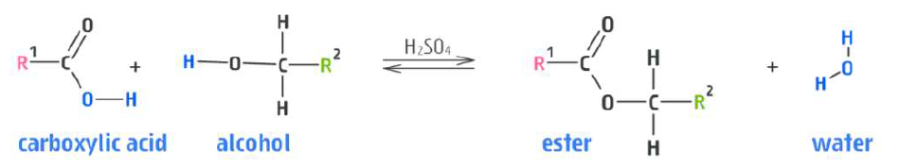
- Reverse reaction occurs when acid is added to ester
- Base added ⇒ Ethanoate Salt + alcohol

Fats and Oils
- Triglycerides ⇒ fats and oils (type of ester)
- Triglycerides contain fatty acid molecules attached to a main ester group
- Vegetable oils are unsuitable for cooking because they remain a liquid when heated
  - Unsaturated fats from plants also tend to spoil quicker (due to more reactive double bounds, capable of addition reactions)
  - Hydrogenation is solution ⇒ converts unsaturated liquid vegetable oils into more versatile solid products (ex. shortening, margarine)
    - Addition reaction where H atoms add to some double bonds in triglyceride carbon chains
    - Reduces degree of unsaturation and produces solid fat
    - Hydrogenation can produce an undesirable side reaction which converts some cis double bonds in triglyceride carbon chain into trans form
      - Trans isomers are unsaturated but their linear geometry increases dispersion forces and allows molecules to pack more efficiently than cis form
        - Trans fats solidify more readily than cis ⇒ poses a risk to cardiovascular system

IMFs
- Intermolecular forces ⇒ forces between molecules
- Dispersion forces ⇒ a temporary dipole that exists as a result of fluctuations in the electron cloud
  - Constantly moving electrons form a temporary dipole
  - All molecules with electrons exhibit dispersion forces
  - Packing density (Steric Hinderance) ⇒ Straight carbon chain molecules exhibit stronger dispersion forces (bent exhibit weaker)
- Dipole-dipole forces ⇒ permanent dipoles
  - Two requirements for molecules to exhibit dipole-dipole:
    - Have to be polar bonds
      - Bonds involving elements with differences in electronegativity
      - Non-symmetrical molecule
  - δ⁺ ⇒ positive dipole
  - δ⁺ ⇒ negative dipole
- Hydrogen-Bonding ⇒ Extreme dipole-dipole bond between very electronegative ion and hydrogen attached to very electronegative ion
  - H-FON (H bonded to F, O or N)
- Mention SUM OF ALL IMFS in answers
- Substitution reactions ⇒ one atom is swapped for another
- Addition reactions ⇒ double bond is broken, creating two reactive sites available for other atoms/molecules to bond
- Types:
  - Halogenation (+ Halogen – F₂, Cl₂ etc)
  - Hydrohalogenation (+ Hydrohalogen – HCl, HF etc)
  - Hydrogenation (+ Hydrogen – H₂)
  - Hydration (+ Water – H₂O)
    - Addition reaction with alkene creates an alcohol (H⁺ and OH⁻ bonds separately)
- Long chain carboxylic acids ⇒
  - Plant fatty acid, unsaturated (oleic acid) in cis configuration
  - Animal fatty acid, saturated (stearic acid)
Model Answer (solubility)
- Detail cohesive forces in solute and how much solute-solute interactions resist mixing
- Detail cohesive forces in potential solvent and how much solvent-solvent interactions resist mixing
- Detail nature of any potential solute-solvent interactions and how much they assist mixing
- If it is soluble, solute-solvent interactions outweigh solute-solute and solvent-solvent forces
Mistakes
- prefixes always in alphabetical order ⇒ only suffixes require priorities
